**DAILY ONLINE ACTIVITIES SUMMARY**

|  |  |  |  |  |  |  |  |
| --- | --- | --- | --- | --- | --- | --- | --- |
| **Date:** | **01/06/2020** | | | | **Name:** | **Churashma** | |
| **Sem & Sec** | **4th SEM 'A' Section** | | | | **USN:** | **4AL18CS019** | |
| **Online Test Summary** | | | | | | | |
| **Subject** | | **Complex analysis, probability and statistical methods.** | | | | | |
| **Max. Marks** | | **30** | | **Score** | | **30** | |
| **Certification Course Summary** | | | | | | | |
| **Course** | **Java programming** | | | | | | |
| **Certificate Provider** | | | **greatlearning academy** | **Duration** | | | **3.5 hours** |
| **Coding Challenges** | | | | | | | |
| **Problem statement 1: Given an array array of size N and an integer K. The task is to find the count of subarrays such that each subarray has exactly K distinct elements.**  **Problem statement 2: Define a class Point with two fields x and y each of type double. Also , define a method distance(Point p1, Point p2) to calculate the distance between points p1 and p2 and return the value in double.. Use Math.sqrt( ) to calculate the square root.** | | | | | | | |
| **Status: completed** | | | | | | | |
| **Uploaded the report in Github** | | | | **yes** | | | |
| **If yes Repository name** | | | | **https://github.com/Churashma/Lockdown-coding** | | | |
| **Uploaded the report in slack** | | | | **yes** | | | |

**ONLINE TEST DETAILS:** Maths test was scheduled from 09:30 am to 10:10am .The portion for the IA was module 5 there were 30 questions and the time assigned was 40 minutes the questions were mcq type.



**CERTIFICATION COURSE DETAILS:**Today I studied about object oriented programming in Java and Inheritance in java. Object Oriented programming is a programming style which is associated with the concepts like class, object, Inheritance, Encapsulation, Abstraction, Polymorphism.An object-based application in Java is based on declaring classes, creating objects from them and interacting between these objects.Inheritance can be defined as the process where one class acquires the properties of another. With the use of inheritance the information is made manageable in a hierarchical order.

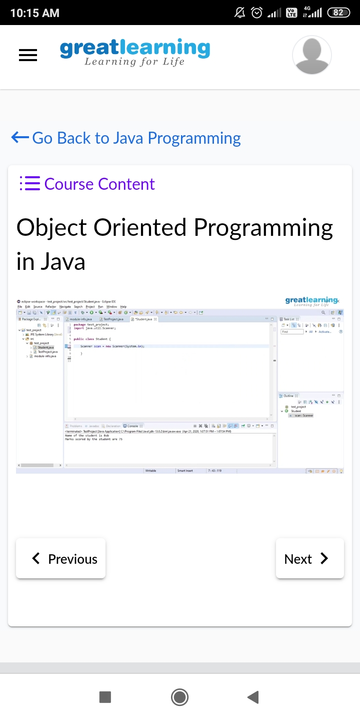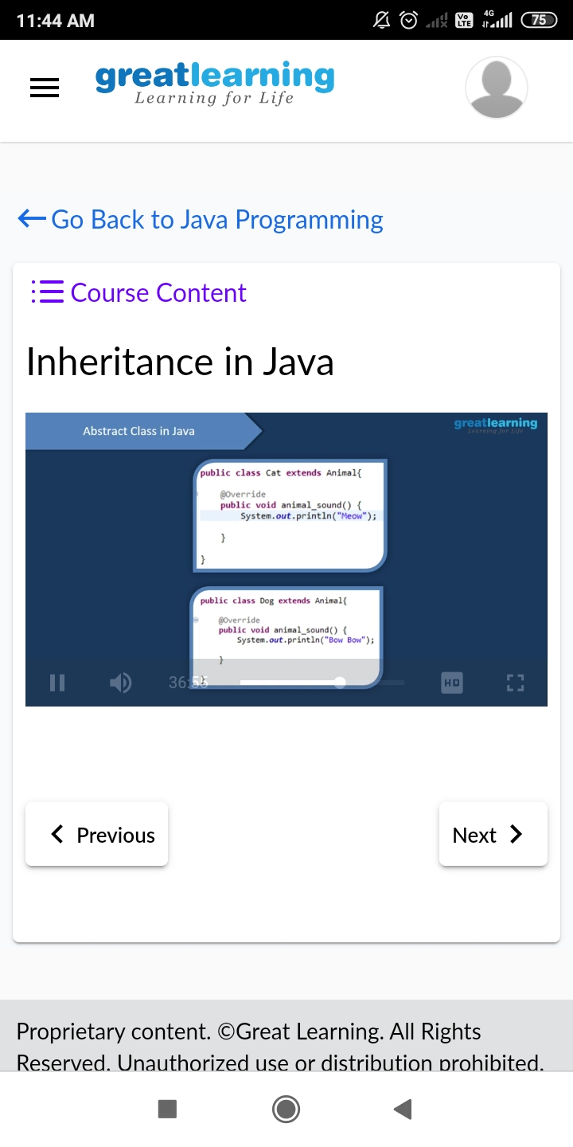

**CODING CHALLENGES DETAILS**:

**Problem statement 1:** Given an array array of size N and an integer K. The task is to find the count of subarrays such that each subarray has exactly K distinct elements.

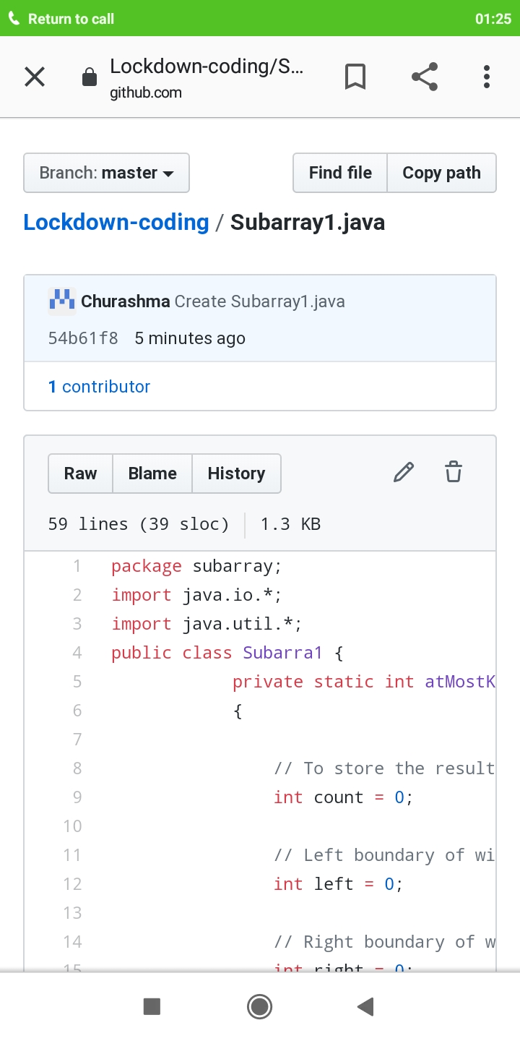

**Problem statement 2:** Define a class Point with two fields x and y each of type double. Also , define a method distance(Point p1, Point p2) to calculate the distance between points p1 and p2 and return the value in double.. Use Math.sqrt( ) to calculate the square root.

